

**MVPS’s**

**RAJARSHI SHAHU MAHARAJ POLYTECHNIC,**

**NASIK**

**INFORAMTION TECHNOLOGY DEPARTMENT**

**ACADEMIC YEAR 2019-20**

**DATA STRUCTURES USING ‘C’**

**(22317)**

MICRO-PROJECT

ON

**“Shop Record System”**

SUBMITTED BY

|  |  |  |  |
| --- | --- | --- | --- |
| **SR. NO** | **ENROLLMENT NO** | **EXAM SEAT NO** | **STUDENT NAME** |
| 25 | 1810020125 |  | Bhavsar Yogesh |
| 2 | 1810020101 |  | Bhavsar Aniket |
| 33 | 1910020070 |  | Kamadi Yogesh |

**Abstract**

In writing the whole record on a book is time-consuming and needs lots of pages and books. Urban planners who are in a position to override market forces must consider whether and how to accommodate or ["demand manage"](https://en.wikipedia.org/wiki/Travel_demand_management) potentially large numbers of data storing at single location. Usually the shop owners write records on books, and more numbers of owners use Microsoft Excel or any other software for data storing and to save space, and may also plan their location and distribution to influence their convenience and accessibility. This information consists of Watch Brand, Serial number and the price and the date at which it is been sold.

**Index**

|  |  |  |  |
| --- | --- | --- | --- |
| **Chapter no** | **Sub Chapter** | **Chapter Name** | **Page no** |
|  |  | Abstract | 2 |
| 1 |  | Introduction | 4 |
| 2 |  | Modeling & Design | 5 |
|  | 2.1 | Algorithm | 5 |
|  | 2.2 | Flowchart | 7 |
| 3 |  | Pseudo code | 11 |
| 4 |  | Output | 18 |
|  |  | Conclusion | 19 |
|  |  | Reference | 20 |

**List of Figures**

|  |  |  |
| --- | --- | --- |
| **Figure no** | **Figure name** | **Page no** |
| 4.1 | Output of Shop Record | 15 |
| 4.2 | Output of Shop Record with serial no & price | 15 |

**Chapter 1**

**Introduction**

Shop Record system is the management of records for an shop. It shows which item its details and how many quantity of that product has been sold.

The activities in this management include the systematic and efficient control of the creation, maintenance, and destruction of the records along with the business transactions associated with them. Considered a key component of operational efficiency, record management adds more value to information assets.

Activities involved in shop records management are:

* Identifying the information which needs to be captured.
* Saving records information.
* Creation of a records storage plan.
* Classification, identification and storing the records.
* Co-ordination of providing internal and external access to the records keeping in view of data privacy and business and data confidentiality.

**Chapter 2**

**Modling & Design**

* 1. **Algorithm.**

Algorithm for Shop Record System.

Step 1: Start

Step 2: Declare Variable Fastrack,Puma,Casio,Titan,Delete,Showdetail

Step 3: If choice = Fastrack

Enter Serial No of Watch

Enter Price of Watch

Enter Date

Count Number of watch

Step 4: If choice = Puma

Enter Serial No of Watch

Enter Price of Watch

Enter Date

Count Number of watch

Step 5: If choice = Casio

Enter Serial No of Watch

Enter Price of Watch

Enter Date

Count Number of watch

Step 6: If choice = Titan

Enter Serial No of Watch

Enter Price of Watch

Enter Date

Count Number of watch

Step 7: If choice = Showdetail

Serial No of all Watche

Price of all Watch

Date at which watch was sold of all watch

Count Number of watch

Step 8: If choice = Fastrack

Enter Serial No of Watch

Enter Price of Watch

Enter Date

Count Number of watch

Step 9: End

**2.2 Flow Chart :**

Start

Declare variable

Enter your Choice

Case 1

Call Fastrack()

Case 2

Call Puma()

Case 3

Call Casio()

Case 4

Call Titan()

Case 5

Call Showdetail()

Case 6

Call Delete()

End

**Function for Fastrack. Function forPuma.**

Enter the Serial No

Count no Watches

Return B

Enter Watch Amount

Enter Date

Enter the Serial No

Count no Watches

Return A

Enter Watch Amount

Enter Date

**Function for Casio.Function for Titan.**

Enter the Serial No

Count no Watches

Return D

Enter Watch Amount

Enter Date

Enter the Serial No

Count no Watches

Return C

Enter Watch Amount

Enter Date

**Function for Show-detail.Function forDelete.**

F

Return F

Delete Whole Record

E

Return E

Show Whole Record

**Chapter 3**

**PseudoCode**

#include<stdio.h>

#include<conio.h>

int count=0,nf=0,f1=0,f2=0,f3=0,f4=0,f5=0,np=0,p1=0,p2=0,p3=0,p4=0,p5=0,nc=0,c1=0,c2=0,c3=0,c4=0,c5=0,nt=0,t1=0,t2=0,t3=0,t4=0,t5=0;

int Menu();

void Fastrack();

void Puma();

void Casio();

void Titan();

void Showdetail();

void Delete();

void main()

{ while(1)

{

clrscr();

switch(Menu())

{

case 1:

Fastrack();

break;

case 2:

Puma();

break;

case 3:

Casio();

break;

case 4:

Titan();

break;

case 5:

Showdetail();

break;

case 6:

Delete();

break;

case 7:

exit(0);

break;

default:

printf("\nInvalid choice");

}

getch();

}

}

int Menu()

{ int ch;

printf("\n\t\t!!!!*****Shop Record System*****!!!!");

printf("\n\t\t\t1.Fastrack");

printf("\n\t\t\t2.Puma");

printf("\n\t\t\t3.Casio");

printf("\n\t\t\t4.Titan");

printf("\n\t\t\t5.Show stutes");

printf("\n\t\t\t6.Delete");

printf("\n\t\t\t7.Exit");

printf("\n\n\t\t\tEnter your choice:");

scanf("%d",&ch);

return(ch);

}

void Showdetail()

{

printf("\n\t\t\tNumber of Fastrack Watch=%d",nf);

printf("\n\t\t\tSerial No=%d",f1);

printf("\n\t\t\tPrice=%d",f2);

printf("\n\t\t\tDate=%d-%d-%d",f3,f4,f5);

printf("\n\n\t\t\tNumber of Puma Watch=%d",np);

printf("\n\t\t\tSerial No=%d",p1);

printf("\n\t\t\t\Price=%d",p2);

printf("\n\t\t\tDate==%d-%d-%d",p3,p4,p5);

printf("\n\n\t\t\tNumber of Casio Watch=%d",nc);

printf("\n\t\t\tSerial No=%d",c1);

printf("\n\t\t\tPrice =%d",c2);

printf("\n\t\t\tDate=%d-%d-%d",c3,c4,c5);

printf("\n\n\t\t\tNumber of Titan Watch=%d",nt);

printf("\n\t\t\tSerial No=%d",t1);

printf("\n\t\t\tPrice =%d",t2);

printf("\n\t\t\tDate=%d-%d-%d",t3,t4,t5);

printf("\n\n\t\t\tTotal Amount of watch sold %d",f2+p2+c2+t2);

printf(“\n\n\t\t\tTotal no of watch sold ”,nf+np+nc+nt);

}

void Delete()

{

nf=0;

f1=0;

f2=0;

f3=0;

f4=0;

f5=0;

np=0;

p1=0;

p2=0;

p3=0;

p4=0;

p5=0;

nc=0;

c1=0;

c2=0;

c3=0;

c4=0;

c5=0;

nt=0;

t1=0;

t2=0;

t3=0;

t4=0;

t5=0;

count=0;

}

void Fastrack()

{ printf("\n\t\t\tEnter Serial No:-");

scanf("\n%d",&f1);

printf("\n\t\t\tEnter Price:-");

scanf("\n%d",&f2);

printf("\n\t\t\tEnter Date:-");

scanf("\n%d",&f3);

printf("\n\t\t\tEnter Month:-");

scanf("\n%d",&f4);

printf("\n\t\t\tEnter Year:-");

scanf("\n%d",&f5);

printf("\n\n\t\t\t*****Entery Successfully*****");

printf("\n\n\t\t\t!!!!!Thank You!!!!!");

nf++;

count++;

}

void Puma()

{ printf("\n\t\t\tEnter Serial No:-");

scanf("\n%d",&p2);

printf("\n\t\t\tEnter Price:-");

scanf("\n%d",&p2);

printf("\n\t\t\tEnter Date:-");

scanf("\n%d",&p3);

printf("\n\t\t\tEnter Month:-");

scanf("\n%d",&p4);

printf("\n\t\t\tEnter Year:-");

scanf("\n%d",&p5);

printf("\n\n\t\t\t*****Entery Successfull*****");

printf("\n\n\t\t\t!!!!!Thank You!!!!!");

np++;

count++;

}

void Casio()

{ printf("\n\t\t\tEnter Serial No:-");

scanf("\n%d",&c1);

printf("\n\t\t\tEnter Price:-");

scanf("\n%d",&c2);

printf("\n\t\t\tEnter Date:-");

scanf("\n%d",&c3);

printf("\n\t\t\tEnter Month:-");

scanf("\n%d",&c4);

printf("\n\t\t\tEnter Year:-");

scanf("\n%d",&c5);

printf("\n\t\t\t*****Entery Successfull*****");

printf("\n\n\t\t\t!!!!!Thank You!!!!!");

nc++;

count++;

}

void Titan()

{ printf("\n\t\t\tEnter Serial No:-");

scanf("\n%d",&t1);

printf("\n\t\t\tEnter Price:-");

scanf("\n%d",&t2);

printf("\n\t\t\tEnter Date:-");

scanf("\n%d",&t3);

printf("\n\t\t\tEnter Month:-");

scanf("\n%d",&t4);

printf("\n\t\t\ttEnter Year:-");

scanf("\n%d",&t5);

printf("\n\t\t\t*****Entery Sucessfull*****");

printf("\n\n\t\t\t!!!!!Thank You!!!!!");

nt++;

count++;

}

**Chapter 4**

**4.1 Output**

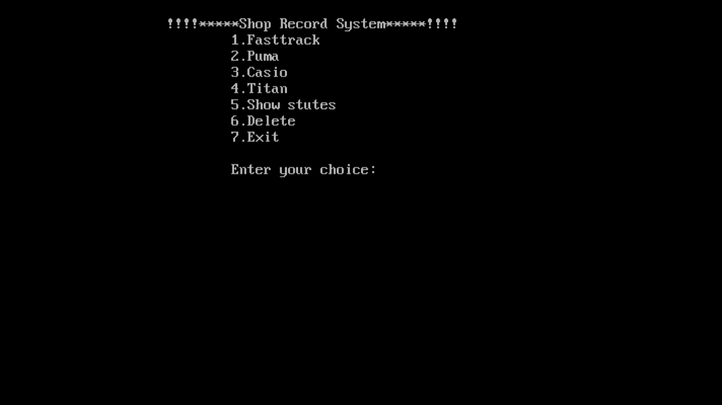

Figure 4.1 (Output of Shop Record)

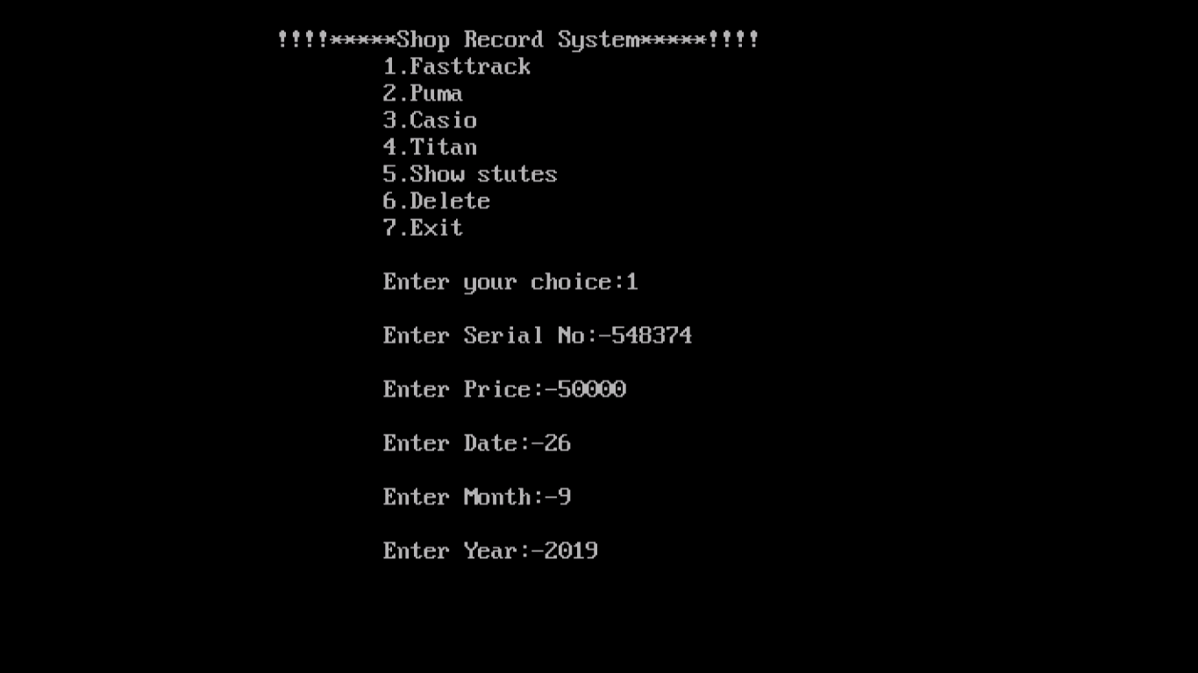

Figure 4.2 (Output of Shop Record with entered info)

**Conclusion**

In order to offer shop record management system, the facility owner need to focus ontwo main factors; first, they are required to identify their unique brand requirements and second, strategies to earn the most from their watches. Because of the significant investment and involvement in shop record management, most of the facility owners decide to expand their resources.

**Reference**

1) Book : Let Us C - author - [Yashavant Kanetkar](https://www.amazon.in/Yashavant-Kanetkar/e/B00JQGKFZY/ref=dp_byline_cont_book_1)

2) Book : Mastering in C - author - [K R Venugopal Sudeep R Prasad](https://www.amazon.in/s/ref=dp_byline_sr_book_1?ie=UTF8&field-author=K+R+Venugopal%3B+Sudeep+R+Prasad&search-alias=stripbooks)